**Abstract**

Internet of Things (IoT) conceptualizes the idea of remotely connecting and monitoring real world objects (things) through the Internet. The concept can be aptly incorporated in a house to make it smarter, safer and automated. The system focuses on building a smart wireless home security system which sends alerts to the owner by using Internet in case of any trespass and raises an alarm optionally. Besides, the same can also be utilized for home automation by making use of the same set of sensors. The leverage obtained by preferring the system over the similar kinds of existing systems is that the alerts and the status sent by the Wi-Fi connected microcontroller managed system can be received by the user on his phone from any distance irrespective of whether his mobile phone is connected to the internet. The current prototype is the NodeMCU board that comes with an embedded micro-controller and an onboard Wi-Fi shield making use of which all the electrical appliances inside the home can be controlled and managed.

**Acknowledgements**

On the very outset of this project report on **“IoT Based Smart Security And Home Automation System”**, we would like to extend our sincere & heartfelt obligation towards all the persons who have helped us in this endeavor. Without their active guidance, help, co-operation & encouragement, we would not have made headway in the project.

We are grateful to our institution **Jawaharlal Nehru National College of Engineering** and the **Department of Computer Science and Engineering** for imparting us the knowledge with which we can do our best.

We would like to thank our beloved guide *Mr. Narendra Kumar S, Assoc. Professor,* Dept.ofComputer Science and Engineering*.* Also, we would like to thank our beloved coordinators *Dr. Poornima.K.M* , *Assoc. Professor* and *Mr. Sayyed Johar*, *Asst. Professor,* Dept.ofComputer Science and Engineering*.* We are highly indebted to them for their guidance and constant supervision as well as for providing necessary information regarding the project & also for their support in completing the project.

We would also like to express our gratitude and thanks to *Dr.* *Nirmala Shivanand*, Professor and Head of the department, Computer Science and Engineering and *Dr. H.R. Mahadevaswamy*, Principal, Jawaharlal Nehru National College of Engineering, Shimoga for all their support and encouragement.

We are thankful to and fortunate enough to get constant encouragement, support and guidance from all Teaching staffs of the Department of Computer Science and Engineering which helped us in successfully completing our project work. Also, I would like to extend our sincere regards to all the non-teaching staff of department of computer science and engineering for their timely support.

Thanking you all,

Preetham Krishna 4JN16CS065

Ramachandra Ashok 4JN16CS072

Sanju B K 4JN16CS085

Shashank l Nagar 4JN16CS090

**Table of Contents:**

|  |  |  |
| --- | --- | --- |
| **Serial Number** | **Contents** | **Page Number** |
| Chapter 1  1.1  1.2  1.3  1.4  1.5 | Introduction  Introduction about IoT  Application of IoT  Overview of the home automation  Existing System  Hardware components required | 1  1  4  6  7  8 |
| Chapter 2 | Problem Statement and objectives | 11 |
| 2.1 | Problem Statement | 11 |
| 2.2 | Objectives of the Project | 11 |
| Chapter 3 | Literature Survey | 12 |
| 3.1 | Bluetooth home automation | 12 |
| 3.2 | Home automation using IoT | 12 |
| 3.3 | Real time smart home automation based on PIC Microcontroller, Bluetooth and Android technology | 13 |
| 3.4 | A step towards home automation using IoT | 13 |
| 3.5 | IoT based smart security and home automation system | 14 |
| 3.6 | Table of Literature survey | 15 |
| Chapter 4 | Design and Implementation | 17 |
| 4.1 | System design | 17 |
| 4.2 | Archietecture for wireless home automation using Raspberry Pi | 20 |
| 4.3 | Wireless using circuits | 21 |
|  | References | 42 |

**List of figures:**

|  |  |  |
| --- | --- | --- |
| **Serial Number** | **Figures** | **Page Number** |
| 1. 1.1 | Block diagram of IoT | 03 |
| 1. 1.2 | Functional block diagram of the system | 06 |
| 1. 1.3 | Existing system | 07 |
| 1. 3.1 | NodeMCU | 08 |
| 1. 3.2 | PIR Sensor | 09 |
| 1. 3.3 2. 3.4 3. 3.5 4. 4.1 5. 4.2 6. 4.3 | Alarm  Relay  GSM  Block diagram for home automation  Architecture for wireless home automation using Raspberry Pi  Working methods using circuits | 09  10  10  17  20  21 |

**Chapter 1**

**INTRODUCTION**

Wireless Home security and Home automation are the dual aspects of this system. The currently built prototype of the system sends alerts to the owner over message using the Internet if any sort of human movement is sensed near the entrance of his house and raises an alarm optionally upon the user’s discretion. The provision for sending alert messages to concerned security personnel in case of critical situation is also built into the system. On the other hand if the owner identifies that the person entering his house is an intruder it send a message to the owner. Such as an intruder found switching on various appliances inside the house, which are also connected and controlled by the micro-controller in the system. The same can be done when the user himself enters the room and by virtue of the system he can make arrangements from his doorstep such that as soon as he enters his house he can make himself at full comfort without manually having to switch on the electrical appliances. Thus using the same set of sensors the dual problems of home security and home automation can be solved on a complementary basis.

The alerts and the status of the IoT system can be accessed by the user from anywhere even where Internet connectivity may not be readily available (since it is not necessary for the mobile phone to be connected to internet only board is required to have an access to Wi-Fi).

The existing Infra-Red (IR) or Blue-tooth remote controls present in the market are in general appliance specific and the same cannot be used interchangeably. Electrical appliances connected through Bluetooth making use of Blue-tooth enabled smart phones cannot be managed from a distant location. Thus functions such as being able to turn on an air-conditioner while returning home cannot be done with such systems. In contrast, this work gives a cost effective and simple solution for wireless home automation and home security systems. The difficulty faced by current home security/surveillance systems in providing information pertaining to the situation to users while being away from home is tried to overcome in the system.

**1.1 Introduction about IoT**

The Internet of Things (IoT) is the network of physical devices, vehicles, home appliances and other items [embedded](https://en.wikipedia.org/wiki/Embedded_system) with [electronics](https://en.wikipedia.org/wiki/Electronics), [software](https://en.wikipedia.org/wiki/Software), [sensors](https://en.wikipedia.org/wiki/Sensor), [actuators](https://en.wikipedia.org/wiki/Actuator), and [connectivity](https://en.wikipedia.org/wiki/Internet_access) which enables these objects to connect and exchange [data](https://en.wikipedia.org/wiki/Data). Each thing is uniquely identifiable through its embedded [computing](https://en.wikipedia.org/wiki/Computing) system but is able to inter-operate within the existing [Internet](https://en.wikipedia.org/wiki/Internet) infrastructure.

Mobile networks already deliver connectivity to a broad range of devices, enabling the development of innovative new services and applications. This new wave of connectivity is going beyond tablets and laptops; to connected cars and buildings; TVs and game consoles; smart meters and traffic control; with the prospect of intelligently connecting almost anything and anyone. This is what the GSMA refers to as the “Connected Life”.

As the Connected Life evolves, the number of mobile connections worldwide is set to rise dramatically to reach 10.5 billion by 2020, while the total number of connected devices across all access technologies could reach 25.6 billion1. These devices will bridge the physical and digital worlds, enabling a new category of services that improve the quality of life and productivity of individuals, society and enterprises.

This Internet of Things - a widely distributed, locally intelligent network of smart devices - will enable extensions and enhancements to fundamental services in education, health and other sectors, as well as providing a new ecosystem for application development.

The Figure 1.1 of online capable devices increased 31% from 2016 to 8.4 billion in 2017. Experts estimate that the IoT will consist of about 30 billion objects by 2020. It is also estimated that the global market value of IoT will reach $7.1 trillion by 2020.

The IoT allows objects to be sensed or controlled remotely across existing network infrastructure, creating opportunities for more direct integration of the physical world into computer-based systems, and resulting in improved efficiency, accuracy and economic benefit in addition to reduced human intervention. When IoT is augmented with sensors and actuators, the technology becomes an instance of the more general class of [cyber-physical systems](https://en.wikipedia.org/wiki/Cyber-physical_system), which also encompasses technologies such as [smart grids](https://en.wikipedia.org/wiki/Smart_grid), [virtual power plants](https://en.wikipedia.org/wiki/Virtual_power_plant), [smart homes](https://en.wikipedia.org/wiki/Smart_home), [intelligent transportation](https://en.wikipedia.org/wiki/Intelligent_transportation) and [smart cities](https://en.wikipedia.org/wiki/Smart_city).

"Things", in the IoT sense, can refer to a wide variety of devices such as heart monitoring implants, [biochip](https://en.wikipedia.org/wiki/Biochip) transponders on farm animals, cameras streaming live feeds of wild animals in coastal waters, automobiles with built-in sensors, DNA analysis devices for environmental/food/pathogen monitoring, or field operation devices that assist firefighters in [search and rescue](https://en.wikipedia.org/wiki/Search_and_rescue) operations. Legal scholars suggest regarding "things" as an "inextricable mixture of hardware, software, data and service".

These devices collect useful data with the help of various existing technologies and then autonomously flow the data between other devices.

There seems to be a general consensus that term “the Internet of things” was coined by [Kevin Ashton](https://en.wikipedia.org/wiki/Kevin_Ashton) of [Procter & Gamble](https://en.wikipedia.org/wiki/Procter_%26_Gamble), later [MIT](https://en.wikipedia.org/wiki/Massachusetts_Institute_of_Technology)'s Auto-ID Center, in 1999. The first written and referable source that mentions the Internet of Things seems to be the White Paper published by the MIT Auto-ID Center in November 2001 (but made public only in February 2002), which cites an earlier paper from October 2000.

The first research article mentioning the Internet of Things appears to be, which was preceded by an article published in Finnish in January 2002. The implementation described there was developed by Kary Främling and his team at Helsinki University of Technology in Finland.

Contrary to the rather RFID and Supply Chain Management view of the Internet of Things, the vision of the Internet of Things presented there was closer to the modern one, i.e. an information system infrastructure for implementing smart, connected objects.

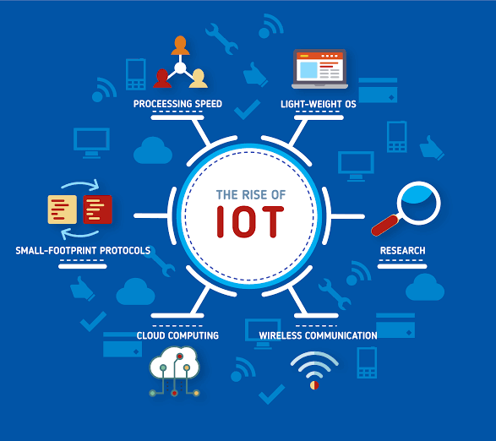

**Figure 1.1 Block diagram of IoT**

IoT is an advanced automation and analytics system which exploits networking, sensing, big data, and artificial intelligence technology to deliver complete systems for a product or service. These systems allow greater transparency, control, and performance when applied to any industry or system.

IoT systems have applications across industries through their unique flexibility and ability to be suitable in any environment. They enhance data collection, automation, operations, and much more through smart devices and powerful enabling technology.

**The advantages of IoT are**

* **Improved Customer Engagement:** Current analytics suffer from blind-spots and significant flaws in accuracy; and as noted, engagement remains passive. IoT completely transforms this to achieve richer and more effective engagement with audiences.
* **Technology Optimization:** The same technologies and data which improve the customer experience also improve device use, and aid in more potent improvements to technology. IoT unlocks a world of critical functional and field data.
* **Reduced Waste:** IoT makes areas of improvement clear. Current analytics give us superficial insight, but IoT provides real-world information leading to more effective management of resources.
* **Enhanced Data Collection:** Modern data collection suffers from its limitations and its design for passive use. IoT breaks it out of those spaces, and places it exactly where humans really want to go to analyze the world. It allows an accurate picture of everything.

**1.2 Application of IoT**

IoT has applications across all industries and markets. It spans user groups from those who want to reduce energy use in their home to large organizations who want to streamline their operations. It proves not just useful, but nearly critical in many industries as technology advances and we move towards the advanced automation imagined in the distant future.

* **Engineering, Industry, and Infrastructure**

Applications of IoT in these areas include improving production, marketing, service delivery, and safety. IoT provides a strong means of monitoring various processes; and real transparency creates greater visibility for improvement opportunities.

The deep level of control afforded by IoT allows rapid and more action on those opportunities, which include events like obvious customer needs, nonconforming product, malfunctions in equipment, problems in the distribution network, and more.

Example: Joan runs a manufacturing facility that makes shields for manufacturing equipment. When regulations change for the composition and function of the shields, the new appropriate requirements are automatically programmed in production robotics, and engineers are alerted about their approval of the changes.

* **Government and Safety**

IoT applied to government and safety allows improved law enforcement, defense, city planning, and economic management. The technology fills in the current gaps, corrects many current flaws, and expands the reach of these efforts.

For example, IoT can help city planners have a clearer view of the impact of their design, and governments have a better idea of the local economy.

Example Joan lives in a small city. She’s heard about a recent spike in crime in her area, and worries about coming home late at night. Local law enforcement has been alerted about the new “hot” zone through system flags, and they’ve increases their presence. Area monitoring devices have detected suspicious behavior, and law enforcement has investigated these leads to prevent crimes.

* **Home and Office**

In daily lives, IoT provides a personalized experience from the home to the office to the organizations we frequently do business with. This improves the overall satisfaction, enhances productivity, and improves the health and safety. For example, IoT can help us customize the office space to optimize the work.

Example Joan works in advertising. She enters her office, and it recognizes her face. It adjusts the lighting and temperature to her preference. It turns on her devices and opens applications to her last working points.

Her office door detected and recognized a colleague visiting her office multiple times before she arrived. Joan’s system opens this visitor’s messages automatically.

* **Health and Medicine**

IoT pushes us towards the imagined future of medicine which exploits a highly integrated network of sophisticated medical devices. Today, IoT can dramatically enhance medical research, devices, care, and emergency care. The integration of all elements provides more accuracy, more attention to detail, faster reactions to events, and constant improvement while reducing the typical overhead of medical research and organizations.

Example: Joan is a nurse in an emergency room. A call has come in for a man wounded in an altercation. The system recognized the patient and pulls his records. On the scene, paramedic equipment captures critical information automatically sent to the receiving parties at the hospital.

The system analyzes the new data and current records to deliver a guiding solution. The status of the patient is updated every second in the system during his transport. The system prompts Joan to approve system actions for medicine distribution and medical equipment preparation.

**1.3 Overview of the Home Automation**

Switches

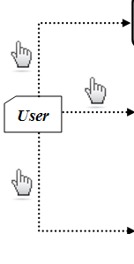

**Home Appliances**

**Sensors**

**Main Control Board**

**Smart Phone**

Android GUI

**PC/Laptop**

window GUI

yagjhsaxiasj

**Figure 1.2 Functional Block Diagram of the System**

Figure 1.2 illustrates the overall control function of the system. The system is directly installed beside the conventional electrical switches on the wall. The Wi-Fi connection enabled the system communicates with graphical user interface (GUI) on PC/laptop or smart phone without cable. The target home appliances are controlled by the system Main Control Board. In order improve the standard living in home.

The sensors that connected to the main control board measure lights, Led and Alarm. The indication from the sensor is able to remind the user to switch on/off the light in the house. The home appliance on/off status GUIs on personal computer or laptop or smart phone. The switches status and sensor reading are in real-time monitoring by the main control board. Any changes on the status or reading will be transmitted to the two GUIs.

**1.4 Existing System**

The infra-red (IR) or Blue-tooth remote controls present in the market are in general appliance specific and the same cannot be used interchangeably. Electrical appliances connected through Bluetooth making use of Blue-tooth enabled smart phones cannot be managed from a distant location. Thus functions such as being able to turn on an air-conditioner while returning home cannot be done with such systems. In contrast, this work gives a cost effective and simple solution for wireless home automation and home security systems. The difficulty faced by current home security/surveillance systems in providing information pertaining to the situation to users while being away from home is tried to overcome in this project.

Power Supply

Microcontroller

Relay

Bluetooth

**Figure 1.3 Existing System**

Figure 1.3 Illustrates the power supply connects to the Bluetooth, relay and microcontroller. The Bluetooth which connects to the microcontroller. Electrical appliances connected through Bluetooth making use of Blue-tooth enabled smart phones cannot be managed from a distant location. Microcontroller connects to the relay. Relay acts as a switch to switch on the light.

**1.5 Literature Survey**

M. N. N. A. Asghar, M.H., “Principle application and vision in internet of things” In this paper the transformations made in embedded computing systems every device got the ability to be uniquely identified. Internet of Things offers advanced connectivity of device, services and covers a variety of protocols, applications. In the concept of IoT, the devices collect useful data with the help of numerous technologies and then flow the data between the devices. IoT had its impact on the lifestyle and it has lead a new dimension in the field of internet.

B. S. S. Tharaniya soundhari, M., “Intelligent interface based speech recognition for home automation using android application,”. The web server is used to connect various hardware to the microcontroller. The android application is used as an interface to transmit the user commands to the web server, which interprets and takes necessary action. Khusvinder Gill et al the system a system which controls the home appliances using a ZigBee remote control locally, and uses the home’s Wi-Fi network for remote controlling of the appliances.

Sunehra and Veena implemented a home automation system for remote controlling of the home appliances through the subject of an email. ElKamchouchi and ElShafee implemented a HAS using SMS service of GSM for remote monitoring and control of home appliances. Also the system includes security features that allow the system to accept commands sent by pre-selected users whose mobile numbers are stored in the database of the HAS.

Nazmul et al the system a touchscreen and remote control based HAS. Here the home appliances are controlled through commands given from a remote controller or a touch screen. The system also operates automatically by detecting the presence of human beings in the room and accordingly the loads are switched off in the absence of any humans.

R.P.Pandav, S.P.Dahatonde, Security System And Home Appliances Control Using IoT, Model of the home automation system. The models consist of different sensors like temperature, gas and motion sensor. Initially the Arduino Uno connects to the Wi-Fi through serial software. When the connection is established it will start reading the parameters of sensors.

B. R. Pavithra, D., “Iot based monitoring and control system for home automation,” explained the model for efficient implementation of IoT in monitoring and controlling the home appliances Via world wide web (www).

Ravi Kishore Kodali, Vishal Jain, Suvadeep Bose and Lakshmi Boppana explained the model for IoT project which includes a smart wireless home security system that sends alerts to house owner through Internet in case of intrusion and raises an alarm if required. The microcontroller used is the TI-CC3200 Launch-Pad board. The status is sent to the user by microcontroller on the mobile phone from anywhere even if the phone has no Internet connectivity.

L.R.Patil, Divya Chopda performed the emergency scheduling of forest fires in order to reduce the operational cost and improve the efficiency of extinguishing fire services.

**1.6 Problem Statement**

The homes can be made smaller, safer and automated by using smart wireless home security system. The system uses a motion sensor to detect any trespass and raises an alarm. The Wi-Fi connected to the system will send and receive notifications. The user can control the system over phone from any distance. The system can be used to control other electrical appliances over phone.

**1.7 Objectives**

The main aim is to build a security system that can detect human presence around the house and display the information to the user in a form, which can be easily understood.

* To detect human movements using PIR motion sensors.
* To trigger an alarm when an intruder entering in the house is detected. An audio signaling sensor is used for this purpose.
* To connect devices various devices to the system using a relay, which acts as a switch for AC devices.
* To send a SMS notifications and control the devices using a GSM module.

**1.8 Organization of the Report**

The Report is organized into six chapters. Chapter 1 gives the over view of the project along with the existing system, problem statement and objective of the system. Chapter 2 discussing the literature survey. The Chapter 3 is about the requirement analysis (hardware and software requirements). Chapter 4 discusses the design and implementation of the system design. Chapter 5 contains snapshots of result, which demonstrate the working of the project and analysis of results. Finally in Chapter 6, Conclusion and Future work is provided in the chapter 6.

**1.9 Summary**

**Chapter 2**

**REQUIREMENT ANALYSIS**

The requirement specification for the home automation it contains the hardware component and software component. The currently built prototype of the system sends alerts to the owner over message using the Internet if any sort of human movement is sensed near the entrance of his house and raises an alarm optionally upon the user’s discretion. The provision for sending alert messages to concerned security personnel in case of critical situation is also built into the system.

**2.1 Functional Requirements**

Functional requirement defines a function of a software or it’s component. A function is described as a set of inputs, the behavior, and outputs. Functional requirements may be technical details, data manipulation, calculations, and the other specific functionality that defines what a system is supposed to accomplish. Some of the functional requirements that are used in the implementation of the Wireless Home security and Home automation are given below:

* + **Accessible WiFi**

ESP8266 is Wi-Fi enabled system on chip (SoC) module developed by Espressif system. It is mostly used for development of IoT (Internet of Things) embedded applications.

* + **PIR motion detector Sensor**

Motion Detection using PIR Sensor a PIR or a Passive Infrared Sensor can be used to detect presence of human beings in its proximity. The output can be used to control the motion of door.

* + **Alarm**

A buzzer or beeper is an audio signaling device, which may be mechanical, electromechanical or piezoelectric.

* + **Relays**

Relays are electromechanical devices which are used to act as a switch for AC devices. Relays are basically controlled by a low power signal.

* + **GSM(SIM 900)**

The SIM 900 is a complete Quad-bank GSM/GPRS solution in SMT model which can be embedded in the customer applications. GSM module is used to establish a communication between a computer and a GSM-GPRS system.

* + **Fire detector sensor**

A Flame detector is a sensor designed to detect and respond to presence of flame or fire, allowing flame detection. A flame detector can often respond faster and more accurately than a smoke or heat detector due to the mechanism it uses to detect the flame.

* + **Smart Door Lock Detector Using Fingerprint Sensor**

We have developed a smart door lock system using a fingerprint sensor to open and close the door. We used Arduino Uno microcontroller and fingerprint sensor , L293D driver IC to drive the dc gear motor and the motor is coupled with the door lock.

**2.2 Non-Functional Requirements**

Non-functional requirements are the requirements that are not delivered by the system but they are character or quality of the system. The attributes are Simplicity, Modeling, Time, Mobility, Security, Safety and Privacy comes under the non-functional requirements. They cannot be specified by the lines of code but they emerge as property from entire work. The important non-functional requirements explained below.

* + **Simplicity:** Simplicity describes the complexity of application development. It involves the interaction between the system and the application developer.
* **Learning:** Targeting usually untrained home end users the composition tool must be easy to learn and simple to use.
* **Building/Changing:** Experienced or trained users should be able to quickly develop or modify even complex applications.
* **Levels of abstraction:** Providing multiple layers of abstraction allows to hide implementation details to end users and to expose them to more advanced developers.
  + **Modeling:** The category deals with requirements that affect the way the smart home applications can be modeled.
* **Expressiveness:** Smart home applications combine information from multiple domains. To make creation of such applications efficient, application developers should be limited in their capabilities to some extent.
  + **Time:** The ability to impose timing constraints on the system is crucial for two reasons. First, smart home applications affect the real world. Second, applications interact with resource-constrained devices which exhibit limited availability and varying delays.
* **Hard real-time:** A system which supports hard real-time guarantees that a certain action is performed within a given time frame. Smart home developers can specify this time frame in application development.
* **Soft real-time:** In contrast to hard real-time, missing a time frame in a soft real-time system is not considered as an error but a quality problem.
* **Synchrony:** Performing actions synchronously or intentionally asynchronously allows the developer to specify that events start or end at the same time.
* **Periods:** For periodical actions application developers must be able to specify both the period of events and a maximum jitter each event may have.
  + **Mobility:** Mobility includes both mobile devices and changes in the system.
* **Discovery:** Discovery enables detection and integration of devices statically during design time or dynamically during runtime. In case of a repository, devices are located based on a match between their capabilities and the user’s preferences.
* **Device Disappearance:** The opposite of discovery denotes the capability of a system to detect when devices or services leave the network and to react accordingly.
* **Location Awareness:** Some applications require location-aware devices and services. Thus application developers should be able to a) find out the location of specific devices and b) find devices with respect to a given location in order to use services of these particular devices.
  + **Security, Safety and Privacy:** Unsafe applications negatively impact devices or the environment in a way which is not foreseen by the developer and must be predicted to ensure process safety. Information of the system should not be visible to anyone except for a defined group of people.
* **Process Safety:** Unsafe applications negatively impact devices or the environment in a way which is not foreseen by the developer and must be predicted to ensure process safety.
* **Confidentiality:** Information of the system should not be visible to anyone except for a defined group of people.
* **Authentication and Authorization:** Enabling confidentiality requires fine grained authentication and authorization mechanisms to access processes, devices and services.
  + **Miscellaneous:**This category contains all requirements that do not match the other categories.
* **Process Integrity:** Concurrent smart home applications should not contradict with each other such contradictions can be detected during design or run time. During design time, the application developer can react accordingly. Capturing contradictions during run time requires the application developer to specify a specific decision in advance.
* **Transaction:** Executing a group of actions with transactional behavior maintains integrity of the application. However, in contrast to IT systems, rolling back actions within transactions is sometimes not possible. The actions may affect the physical world, which sometimes does not foresee being reverted.
* **Resource management:** Often cooperation with resource-constrained devices relies on a trade-off between functionality and resource constraints. It should be possible to specify how the application reacts to changing resources.

**2.3 Hardware Components Required**

The hardware requirements for the implementation of our project are:-

* Aurdino UNO
* Accessible WIFI
* PIR motion detector Sensor
* Alarm
* Relays for connecting home appliances, electromechanically controlled doors or windows.
* Mobile phone to receive message
* GSM(SIM 900)
* Radio-Frequency Identification (RFID)
* Servo Motor
* Potentiometer
* Smoke sensor
* LCD DISPLAY
* Smart door lock detector using Fingerprint Sensor
* **Aurdino UNO**

The **Arduino Uno** is an open-source microcontroller board based on the Microchip ATmega328P microcontroller and developed by **Arduino**.cc. The board is equipped with sets of digital and analog input/output (I/O) pins that may be interfaced to various expansion boards (shields) and other circuits.

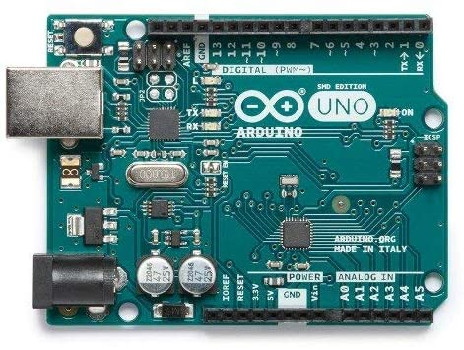

**Figure 2.1 Aurdino UNO**

* **Wi-Fi Module**

ESP8266 is Wi-Fi enabled system on chip (SoC) module developed by Espressif system. It is mostly used for development of IoT (Internet of Things) embedded applications. Figure 3.1 the ESP8285 is an ESP8266 with 1 MB of built-in flash, allowing for single-chip devices capable of connecting to Wi-Fi. The ESP8266 wi-Fi module is a self-contained SoC with integrated TCP/IP protocol stack that can give any microcontroller access to your Wi-Fi network. The ESP8266 is capable either hosting an application offloading all Wi-Fi networking functions from another application processor.

* **PIR Sensor**

Motion Detection using PIR Sensor a PIR or a Passive Infrared Sensor can be used to detect presence of human beings in its proximity. The output can be used to control the motion of door. The lens on the sensor focuses any infrared radition present around it toward the infrared detector. The bodies generate infrared detector. Our bodies generate infrared heat, and this heat is detected by the motion sensor. When the PIR motion sensor detects a person, it outputs a 5V signal to the Arduino and trigger an interrupt n 3.2.

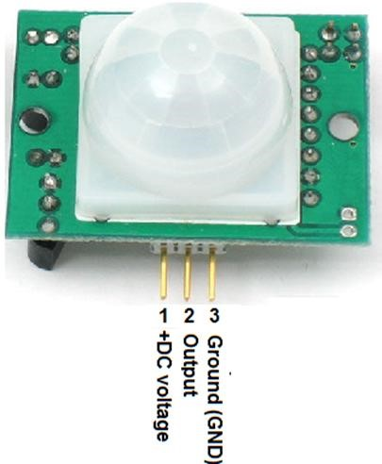

**Figure 2.2 PIR Sensor**

* **Alarm**

A buzzer or beeper is an audio signaling device, which may be mechanical, electromechanical or piezoelectric. In this system detecting objects it uses an ultrasonic sensors, and once the alarm detect something a buzzer start emitting a sound Figure 3.3.



**Figure 2.3 Alarm**

* **Relay**

Relays are electromechanical devices which are used to act as a switch for AC devices. Relays are basically controlled by a low power signal. Figure 3.4 this is a very simple circuit that allows a relay to be open and closed with a switch. For this system, the arduino is not necessary but for many future system it is needed. A relay can allow a 5V current from an Arduino to switch on/off a much higher voltage circuit without damaging the arduino.

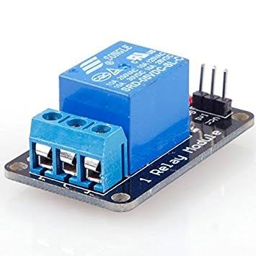

**Figure 2.4 Relay**

* **GSM(SIM 900)**

The SIM 900 is a complete Quad-bank GSM/GPRS solution in SMT model which can be embedded in the customer applications. GSM module is used to establish a communication between a computer and a GSM-GPRS system. Global system for mobile communication (GSM) is an architecture used for mobile communication in most of the countries. Global packet radio service(GPRS) is an extension of GSM that enables higher data transmission rate Figure 3.5.

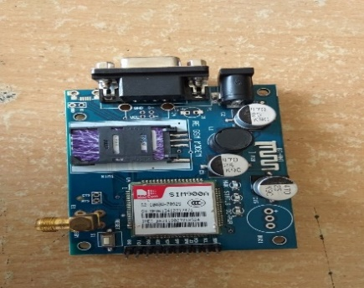

**Figure 2.5 GSM**

* **Radio-Frequency Identification (RFID)**

Radio-Frequency Identification (RFID) is the use of radio waves to read and capture information stored on a tag attached to an object. A tag can be read from up to several feet away and does not need to be within direct line-of-sight of the reader to be tracked.

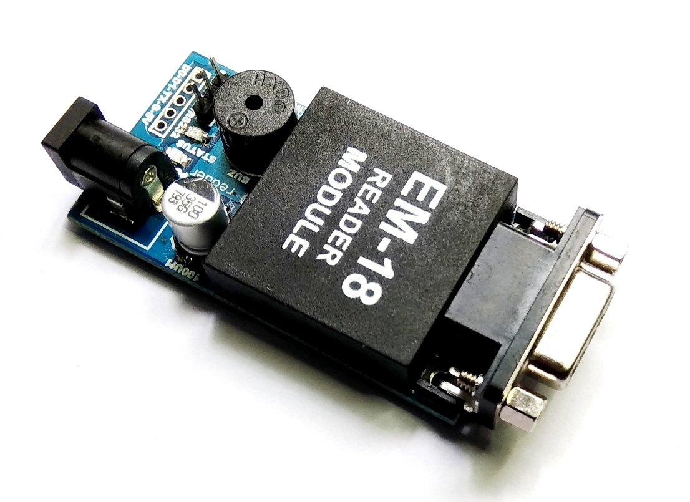

**Figure 2.6 RFID**

* **Servo Motor**

A **Servo Motor** is a small device that has an output shaft. This shaft can be positioned to specific angular positions by sending the **servo** a coded signal. As long as the coded signal exists on the input line, the **servo** will maintain the angular position of the shaft.

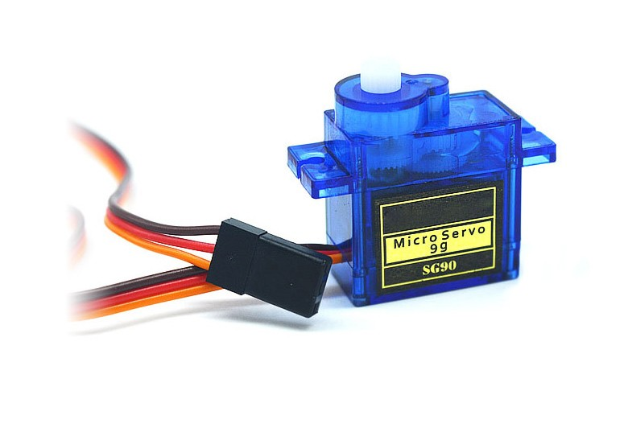

**Figure 2.7 Servo Motor**

* **Potentiometer**

A **potentiometer** is a simple mechanical device that provides a varying amount of resistance when its shaft is turned. By passing voltage through a **potentiometer** and into an analog input on your board, it is possible to measure the amount of resistance produced by a **potentiometer** (or pot for short) as an analog value.

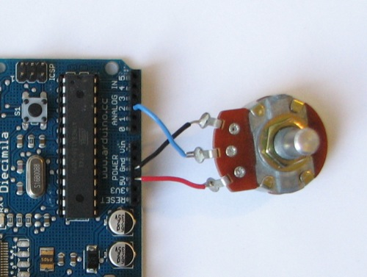

**Figure 2.8 Potentiometer**

* **Smoke sensor**

In smoke sensoryou can connect it to 5V output from your **Arduino**. GND is the Ground Pin and needs to be connected to GND pin on the **Arduino**. D0 provides a digital representation of the presence of combustible gases. A0 provides analog output voltage in proportional to the concentration of **smoke**/gas.

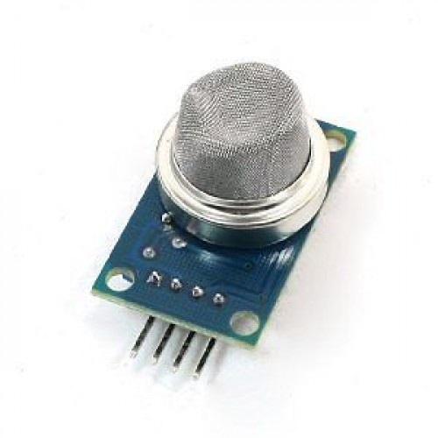

**Figure 2.9 Smoke sensor**

* **LCD DISPLAY**

The Liquid Crystal() function sets the pins the **Arduino** uses to connect to the **LCD**. You can use any of the **Arduino's** digital pins to control the **LCD**. Just put the **Arduino** pin numbers inside the parentheses in this order: Liquid Crystal(RS, E, D4, D5, D6, D7). RS, E, D4, D5, D6, D7 are the **LCD** pins.

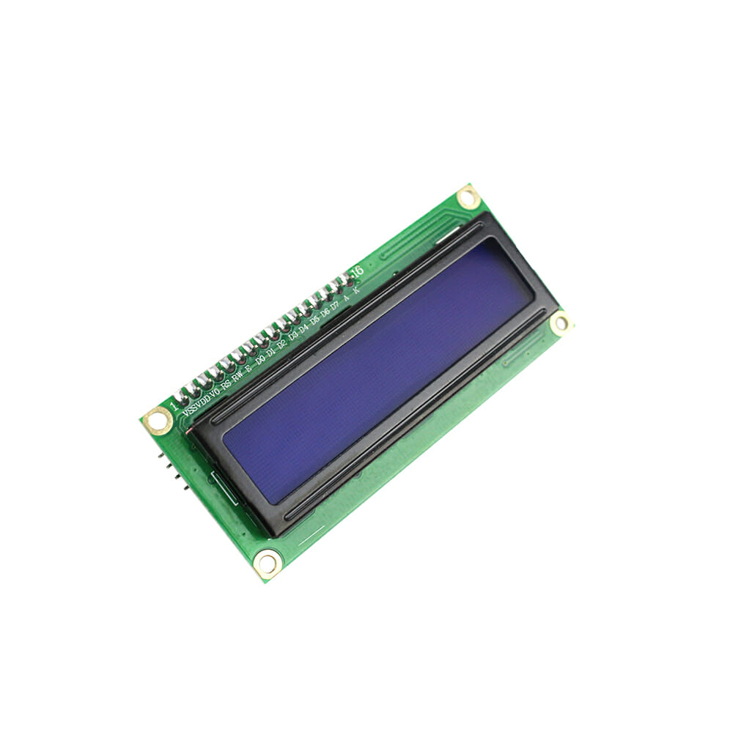

**Figure 2.10 LCD display**

**2.4 Software Requirement**

* **Arduino IDE**

Arduino consists of both a physical programmable circuit board (often referred to as a microcontroller) and a piece of software, or IDE (Integrated Development Environment)that runs on your computer, used to write and upload computer code to the physical board.

The Arduino platform has become quite popular with people just starting out with electronics, and for good reason. Unlike most previous programmable circuit boards, the Aurdnio does not need a separate piece of hardware (called a programmer) in order to load new code onto the board it can simply use a USB cable. Additionally, the Arduino IDE uses a simplified version of C++, making it easier to learn to program. Finally, Arduino provides a standard form factor that breaks out the functions of the micro-controller into a more accessible package.

Arduino board designs use a variety of microprocessors and controllers. The boards are equipped with sets of digital and analog input/output pins that, may be interfaced to various expansion boards or breadboard and other circuits. The boards feature serial communications interfaces, including Universal Serial Bus (USB) on some models, which are also used for loading programs from personal computers. The microcontrollers are typically programmed using a dialect of features from the programming languages C and C++. In addition to using traditional complier tool chains, The Arduino project provides an integrated development environment (IDE) based on the processing language project.



**Figure 2.11 Aurdino IDE**

**2.5 Design Issues**

* When we are designing the project, we will come across various issues regarding the system they can be.
* Home automation and security system should provide a user- friendly interface to allow setup, monitoring and controlling home appliance easily and efficiently. In addition, the automation system should be fast enough and provide reliable connection with acceptable data rate and communication range to realize the true power of wireless technology .
* Finally, the system controller should be cost effective to allow public users to possess and justify its application in home automation.

**2.6 Summary**

The requirement analysis it contains the hardware components and software components and functional requirements. It holds all these description and its design of the system and the requirements for the system.

**Chapter 3**

**DESIGN AND IMPLEMENTATION**

The system sends alerts to the owner over message using the Internet if any sort of human movement is sensed near the entrance of his house and raises an alarm optionally upon the user’s discretion. The provision for sending alert messages to concerned security personnel in case of critical situation is also built into the system.

**4.1 System Design**

The system architecture of Home Automation using Internet of Things is shown in Figure 4.1. Following are the main components of the system:

* **PIR Sensor:** Motion Detection using PIR Sensor a PIR or a Passive Infrared Sensor can be used to detect presence of human beings in its proximity. The output can be used to control the motion of door. Basically motion detection use light sensors to detect either the presence of infrared light emitted from a warm objector absence of infrared light when a object interrupts a beam emitted by another part of the device. A PIR sensor detects the infrared light radiated by a warm object.
* **Working of PIR Motion Sensor:** PIR sensors allow you to sense motion, almost always used to detect whether a human has moved in or out of the sensors range. They are small, inexpensive, low-power, easy to use and don't wear out. For that reason they are commonly found in appliances and gadgets used in homes or businesses. They are often referred to as PIR, "Passive Infrared", "Pyroelectric", or "IR motion" sensors.

PIRs are basically made of a pyroelectric sensor, which can detect levels of infrared radiation. Everything emits some low level radiation, and the hotter something is, the more radiation is emitted. The sensor in a motion detector is actually split in two halves. The reason for that is that we are looking to detect motion (change) not average IR levels. The two halves are wired up so that they cancel each other out. If one half sees more or less IR radiation than the other, the output will swing high or low.

The PIR sensor itself has two slots in it, each slot is made of a special material that is sensitive to IR. The lens used here is not really doing much and so we see that the two slots can 'see' out past some distance (basically the sensitivity of the sensor). When the sensor is idle, both slots detect the same amount of IR, the ambient amount radiated from the room or walls or outdoors. When warm bodies like a human or animal passes by, it first intercepts one half of the PIR sensor, which causes a positive differential change between the two halves. When the warm body leaves the sensing area, the reverse happens, where by the sensor generates a negative differential change. These change pulses are what is detected.

* **Wi-Fi Module:** ESP8266 is Wi-Fi enabled system on chip (SoC) module developed by Express if system. It is mostly used for development of IoT (Internet of Things) embedded applications**.** The ESP8285 is an ESP8266 with 1 MB of built-in flash, allowing for single-chip devices capable of connecting to Wi-Fi.
* **Relay:** Relays are electromechanical devices which are used to act as a switch for AC devices. Relays are basically controlled by a low power signal.
* **Appliance:** The various appliances include lights, fans, electronic door latches and security camera.
* **MCU:** A microcontroller (or MCU, short for microcontroller unit) is a small computer (SoC) on a single integrated circuit containing a processor core, memory, and programmable input/output peripherals. Program memory in the form of Ferroelectric RAM, NOR flash or OTP ROM is also often included on chip, as well as a typically small amount of RAM. Microcontrollers are designed for embedded applications, in contrast to the microprocessors used in personal computers or other general purpose applications consisting of various discrete chips.

The design has its own application to control the various home appliances and also to monitor the security features. User can interact with the application to carry out various functions. The user will receive alerts on the application if there is any attempt to break in to their home. This further adds security to the system. The data is received only by the server at the specified port and gets analyzed further. This project proposes a system that is different from existing ones as it has its own software application of providing state-of-the-art security.

Internet

User

Mobile Hotspot

PIR Sensor

Light

Relay

Node MCU

Buzzer

LED

GSM Module

Power Supply

**Figure 4.1 Block diagram for Home Automation**

The system model of the home automation system is as shown in the Figure 4.1 The models consist of PIR motion sensor. Initially the NodeMCU connects to the GSM Module through software. When the connection is established it will start reading the parameters of sensor. If the sensor parameters level is then the respective alarm will be raised and send message to the authorized person.

In the system model the motion sensor house is monitored. When an one unauthorized person are enter in home the PIR sensor is active and home alarm is on as well as red light is on. The required lights, LED and PIR sensor are turned on/off by using the web server. The user can also monitor the electric appliances through the internet via web server. If the lights or any electrical appliances are left on in home can be seen and turned off remotely through simply typing the IP address of the web server.

**4.1.1 Working of Prototype**

The prototype can be used in following two ways.

* As a smart security system
* As a smart home automation system
* **As a Smart Security System**

PIR motion sensors are installed at the entrances of a building. These sensors as explained earlier detect the motion of human beings. This signal which detects their presence becomes the input trigger for the micro-controller. The owner, who may or may not be present in that building, will be receiving a messageon his mobile phone (whose number is predefined in the program) stating that ’There is an Intruder in the House’.

To turn ON the lights and alarm at house so that the intruder will be warned, the owner can press ’1’ from his mobile keypad. Moreover if the owner finds that his building is not safe, he can send an SMS to the concerned authority in police department; explaining his situation. The module will turn OFF the alarm and lights after a fixed time delay. The call will be triggered again as soon as the module detects any unexpected motion and the owner will receive the call again and the process continues so on. (To ensure the safety from other entrances too, motion sensor should be installed at those places and will be controlled by a single micro-controller).

* **As a Smart Home Automation System**

This application of the module can be explained by an example. Suppose the owner is expecting a guest at his house but he is not available there. Now, as the guests reach at his house the owner will receive a video call. But now the owner can press digits other than 1 (such as 3 for lights, 4 for fan, 5 for A.C., and so on) or even can disable the security system. Similarly if the user or somebody leaves the house, the user will still receive a video call and this time he can switch off the appliances or can enable the security system again by pressing proper digits known to him. Since the appliances are connected to mains supply through a relay they can be easily controlled using micro-controller.

**4.2 Implementation**

In the system will be in idle state. If PIR sensor detected any sort of human movement then it send alert to the owner over message else system will be in idle state if owner find the entering person he an intruder then system arise alarm optionally upon user discretion and send message to owner an intruder is found and then it go to idle state. If he is not an intruder then it switch on the led and switch on the light through mobile phone Figure 4.2.

Start

Idle

Motion Detected?

No

|  |
| --- |
|  |

Yes

Message sent through Internet

|  |
| --- |
|  |

Intruder there ?

?

Yes

|  |
| --- |
|  |

No

Switch 1 LED

Switch 2 Light

Switch 3 PIR sensor

Alarm

|  |
| --- |
|  |

**Figure 4.2 Flow chart for the Home automation System**

**4.3 NodeMCU Programming API’s**

* **handle.login() :-** Most of the time handle.login() hanging forever.It uses three parameters are IP/host, user name and password.

* **handle.commit() :-** after commit manager reboots. on server reboot boot Handel is not able to establish the connection.
* **setup() :-** setup() function is called when a sketch starts. Use it to initialize variables, pin modes, start using libraries, etc. The setup() function will only run once, after each power up or reset of the NodeMCU board.
* **pinMode() :-** If the pin has been configured as an OUTPUT with pinMode(), its voltage will be set to the corresponding value: 5V for HIGH, 0V for LOW. It is recommended to set the pinMode() to INPUT_PULLUP to enable the internal pull-up resistor.

**Syntax**

pinMode(pin, mode)

**Parameter**

**pin:** The number of the pin whose mode you wish to set.

**mode:** INPUT, OUTPUT, or INPUT_PULLUP.

* **digitalWrite() :-** If the pin is configured as an INPUT, digitalWrite() will enable (HIGH) or disable(LOW) the internal pullup on the input pin.

**Syntax**

digitalWrite(pin, value)

**Parameters**

**pin:** the pin number.

**value:** HIGH or LOW.

* **begin() :-** sets the data rate in bits per second (baud) for serial data transmission. For communicating with the computer, use one of these rates: 300, 600, 1200, 2400, to 115200.

An optional second argument configures the data, parity, and stop bits. The default is 8 data bits, no parity, one stop bit.

**Syntax**

Serial.begin(speed)

Serial.begin(speed,config)

**Parameters**

**speed:** in bits per second(baud)-long.

**config:** sets data, parity, and stop bits.

**loop():-** After creating setup() function, which initializes and sets the initial values, the loop() function does precisely what its name suggests, and loops consecutively, allowing your program to change and respond. Use it to actively control the NodeMCU board.

* **digitalRead() :-** Reads the value from a specified digital pin, either HIGH or LOW.

**Syntax**

digitalRead(pin).

**Parameters**

**pin:** the number of the digital pin you want to read.

* **print():-** Prints data to the serial port as human-readable ASCII text. This command can take many forms. Numbers are printed using an ASCII character for each digit. Floats are similarly printed as ASCII digits, defaulting to two decimal placed. Bytes are sent as a single character. Characters and strings are sent as is.

An optional second parameter specifies the base(format) to user; permitted value are BIN(binary, or base), OCT(octal, or base 8), DEC(decimal, or base 10), HEX(hexadecimal, or base 16). For floating point numbers, this parameter specifies the number of decimal places to use.

**Syntax**

Serial.print(val)

Serial.print(val, format)

**Parameter**

**val:** the value to print-any data type.

**format:** specifies the number base(for integral data types) or number of decimal places(for floating point types).

* **println() :-** prints data to the serial port as human-readable ASCII text followed by a carriage return character(ASCII 13, or ‘\r’) and a newline character(ASCII 10, or ‘\n’). This command takes the same forms as Serial.println().

**Syntax**

Serial.println(val)

Serial.println(val, format)

**Parameter**

**val:** the value to print-any data type.

**format:** specifies the number base(for integral data types) or number of decimal places(for floating point types).

* **WiFi.begin() :-** Initializes theWiFi library’s network settings and provides the current status.

**Syntax:**

WiFi.begin();

WiFi.begin(ssid);

WiFi.begin(ssid, pass);

WiFi.begin(ssid, keyIndex, key);

**Parameter**

**ssid:** the SSID(Service Set Identifier) is the name of the WiFi network you want to connect to.

**keyIndex:** WEP encrypted networks can hold up to 4 different keys. This identifies which key you are going to use.

**key:** a hexadecimal string used as a security code for WEP encrypted networks.

**pass:** WPA encrypted networks use a password in the form of a string for security.

* **Returns**

**WL_CONNECTED** when connected to a network.

**WL_IDLE_STATUS** when not connected to a network, but pawered on.

**hasArg() :-** Returns TRUE if name corresponds to an argument in the call, either a formal argument to the function, or a component of.., and FALSE otherwise.

**Syntax**

hasArg(name)

**Parameters**

**name:** The name of a potential argument, as an unquoted name or character string.

* **header() :-** The header() function sends a raw HTTP header to a client. It is important to notice that header() must be called before any actual output is sent.

**Syntax**

Header(string, replace, http_response_code)

**Parameter**

**string :-** Required. Specifies the header string to send.

**replace :-** Optional. Indicates whether the header should replace previous or add a second header. Default is TRUE(will replace). FALSE (allows multiple headers of the same type).

**http_response_code :-** Optional. Forces the HTTP response code to the specified value.

* **delay() :-** Pauses the program for the amount of time(in milliseconds) specified as parameter. (There are 1000 milliseconds in a second).

**Syntax**

delay(ms)

**Parameter**

**ms:** the number of milliseconds to pause (unsigned long).

* **Send() :-** The send() function shall initiates transmission of a message from the specified socket to its peer. The send() function shall send a message only when the socket is connected(including when the peer of a connectionless socket has been set via connect()).

**Syntax**

Send(int socket, const void *buffer, size_t length, int flags);

**Parameters**

**Socket** :- specifies the socket file descriptor.

**Buffer** :- Points to the buffer containing the message to send.

**Length** :- specifies the length of the message in bytes.

**Flags** :- specifies the type of message transmission.

* **ESP8266WiFi.h :-** The Wi-Fi library for ESP8266 has been developed based on ESP8266 SD, using naming convention and overall functionality philosophy of Aurdino WiFi library. Over time the wealth Wi-Fi features ported from ESP9266 SDK to esp8266 / Aurdino outgrew Aurdino WIFi library and it became apparent that need to provide separate documentation on what’ is new and extra.

This documentation will walk you through several classes, methods and properties of ESP8266WiFi library.If you are new to c++ and Aurdino, don’t worry. This will start from general concepts and then move to detailed description of members of each particular class including usage examples.

The scope of functionality offered by ESP8266WiFi library is quite extensive and therefore this description has been broken up into separate documents marked with :arrow _right.

* **WiFiClient() :-** Creates a client that can connect to a specified internet IP address and port as defined in client.connect().

**Syntax**

WiFiclient()

**4.4 Summary**

The design and implementation it contains the working of the sensor. Sensor will sense the intruder is entering the home it send a signal and it provide a security for home automation system and the NodeMCU programming API’s function it can contain.

**Chapter 5**

**RESULT AND ANALYSIS**

The system sends alerts to the owner over message using the Internet if any sort of human movement is sensed near the entrance of his house and raises an alarm optionally upon the user’s discretion. The provision for sending alert messages to concerned security personnel in case of critical situation is also built into the system. On the other hand if the owner identifies that the person entering his house is an intruder it send a message to the owner.

**5.1 Experimental Status**

Figure 5.1 this is circuit connection for the home automation and it includes NodeMCU board and buzzer it trigger when intruder is found. Sensor will sense the intruder is found or not. Relay it acts as a switch and the light will be glow. GSM module it send a message to the owner.

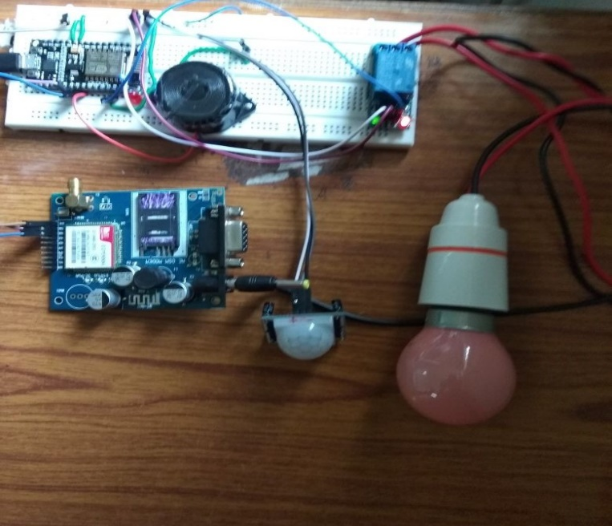

**Figure 5.1 Connection of home automation**

**5.2 Wi-Fi status display**

Figure 5.2 it display the serial monitor screen to see the IP address of the web page and it display the Wi-Fi connection is enabled or disabled and the intruder is found or not are displayed in the serial monitor.

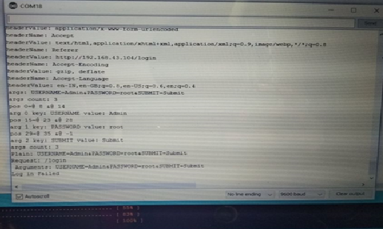

**Figure 5.2 Display Screen**

**5.3 Login Page**

Figure 5.3 IP address can be copy and paste it in the google it creates a web form login page it creates a user name and the password. User name is “admin” and Password name is “root” then submit the button.

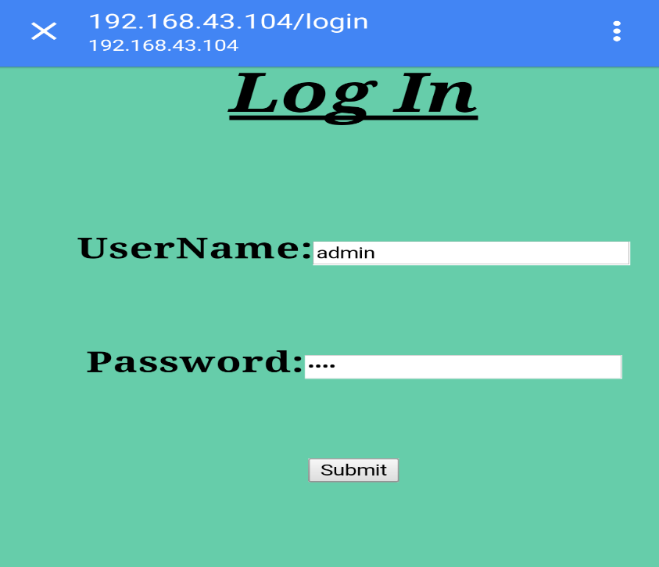

**Figure 5.3 Login web page**

**5.4 Home Automation Page**

Figure 5.4 after the submit button press home automation page will be open it contains switch on the Led, Light, and pir monitoring. if press Led is ON then Led glows same thing for other appliances.

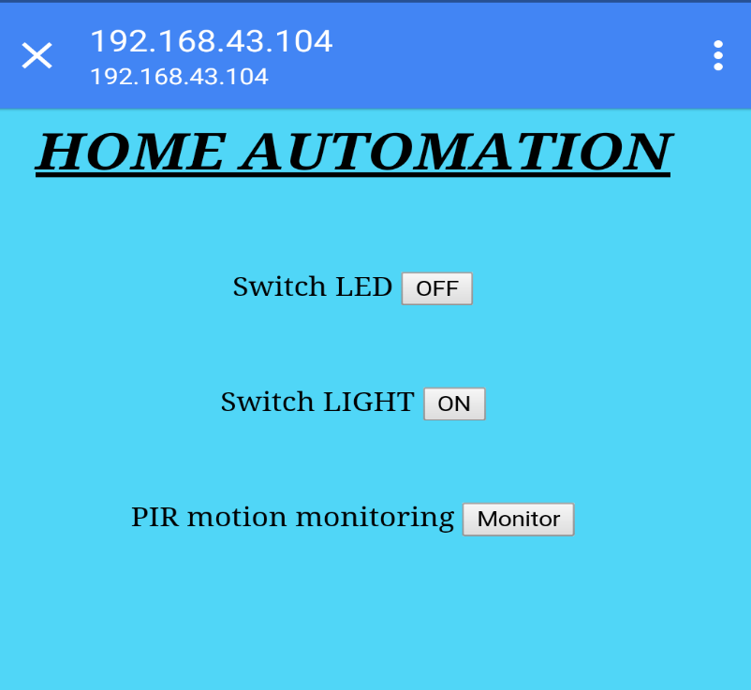

**Figure 5.4 Home Automation page Switch on the Led**

**5.5 Alert System**

Figure 5.5 in the mobile phone if press switch LED is ON then displays Led is ON. If you press OFF button the Led will be OFF.

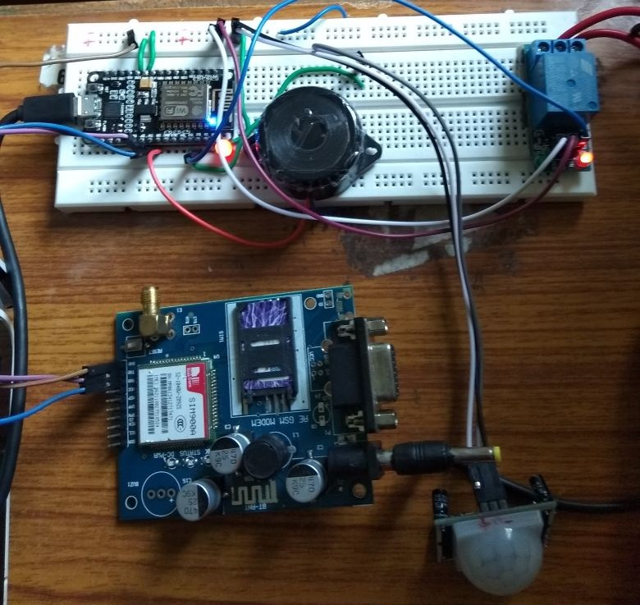

**Figure 5.5 Led glow**

Figure 5.6 in the mobile phone if press switch LIGHT then it display Light is ON If you press OFF then Light is OFF.

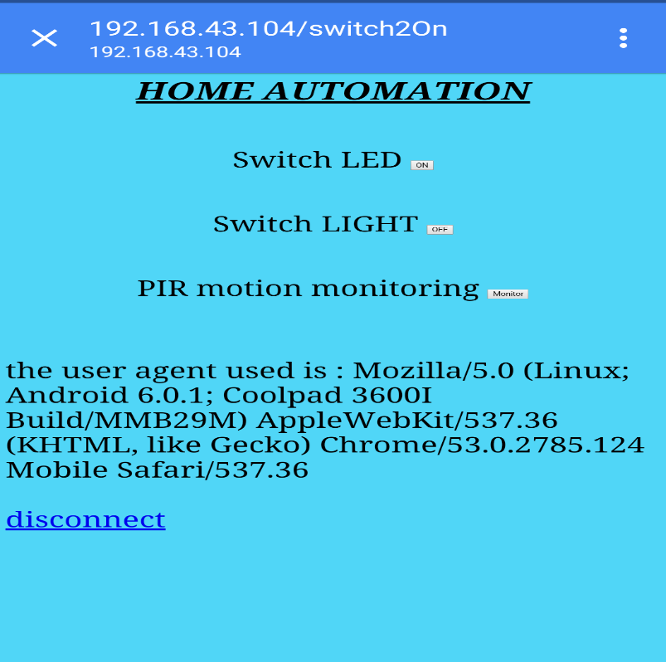

**Figure 5.6 Home Automation page Switch on the Light**

Figure 5.7 in the mobile phone if press ON Light will be glowing if press OFF then light will be OFF.

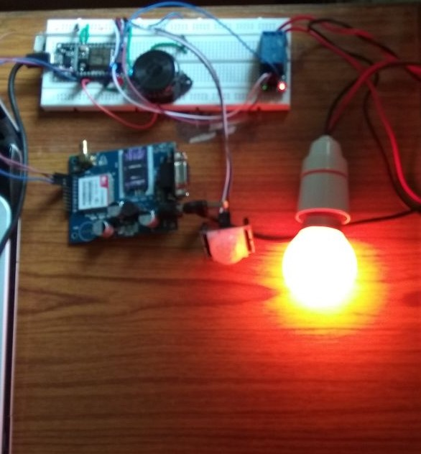

**Figure 5.7 Light glow**

Figure 5.8 In GSM module it send a message to the owner when intruder found in the house it display a “An INTRUDER is found” and owner can replay to that message.

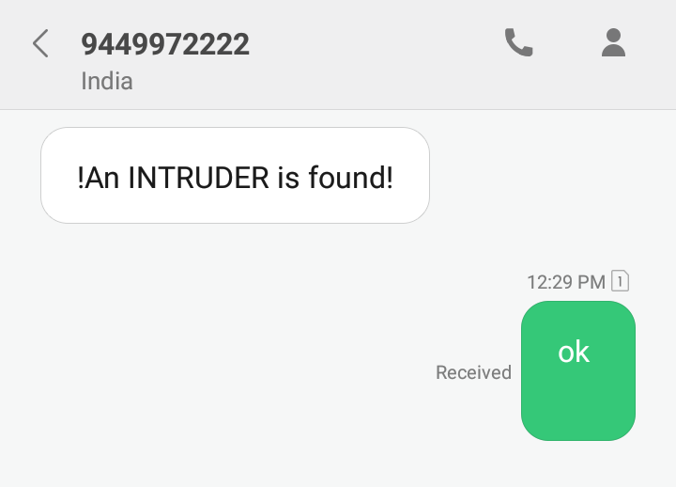

**Figure 5.8 GSM module send a message**

**5.6 Summary**

The result and analysis it contains circuit connection and it has IP address connect to the mobile phone. It has a web page this page contain the user name and the password and the home page it contains the switch on the LED and switch on the LIGHT and switch on PIR monitoring if press ON button the appliances will be ON if press OFF then appliances will be OFF.

**Chapter 6**

**CONCLUSION**

The security system and home appliances control using Internet of Things has been implemented. By connecting simple appliances to it and the appliances were controlled remotely over the internet. The designed system not only monitor the sensor data, light, motion sensors, and actuates a process according to the requirement, such as sending an alert message and raising an alarm. This will help the user to analyze the condition of various parameters in the home anytime anywhere. The prime objective of the system is to use a Smartphone to control home appliances, Passive Infrared Sensor can be used to detect presence of human beings in its proximity, Relays are electromechanical devices which are used to act as a switch for AC devices, GSM module is used to establish a communication between a computer and a GSM-GPRS system, effectively and to provide robust home security and safety measures.

**6.1 Future Scope**

The home automation system can further be improved to include a camera and user can take decisions whether to activate the security system or welcome the guest. Further the system can be enhanced integrating the voice commands through which the user can control the home appliances with any voice call being triggered to the phone.

**REFERENCES**

[1] Ravi Kishore Kodali, Vishal Jain, Suvadeep Bose and Lakshmi Boppana, “IoT Based Smart Security and Home Automation System” 2016 IEEE.

[2] M. N. N. A. Asghar, M.H., “Principle application and vision in internet of things (IOT),” in Communication Technologies (GCCT), 2015 Global Conference, May 2015.

[3] A. R. C. Y. O. K. Withanage, C., “A comparison of the popular home automation technologies”, pp. 1 – 11, May 2014.

[4] B. R. Pavithra, D., “IOT based monitoring and control system for home automation”, pp. 169 – 173, April 2015.

[5] M. J. H. B. T. A. M. K. T. Baig, M.Q. “Artificial intelligence, modeling and simulation”, 2014 2nd international conference pp. 109–114, November 2014.

[6] B. S. S. Tharaniya Soundhari, M., “Intelligent interface based speech recognition for home automation using android application”, pp. 1 – 11, March 2015.

[7] F. M. G. K. D. Sukmana, Husni Teja, “Wireless and mobile (apwimob), 2015 IEEE Asia pacific conference,” pp. 183 – 187, August 2015.

[8] S. E. T. B. C. A. Urfaliglu, O., “Signal processing, communication and applications conference, 2008. IEEE 16th,” pp. 1–4, April 2008.

[9] E. A. Elkamchouchi, H., “Design and prototype implementation of SMS based home automation system,” pp. 162 – 167, November 2012.

[10] O. N. C. S. A. P. B. Sahani, M, “Circuit, Power and Computing technologies”, 2015 international conference on, pp. 1–6, March 2015.

[11] T. Ming Zhao, Chua, “Automatic face and gesture recognition”, 2008 international conference on, pp. 1–6, September 2008.

[12] Ravi Kishore Kodali, Vishal Jain, Suvadeep Bose and Lakshmi Boppana "IoT Based Smart Security and Home Automation System", 2016: http://ieeexplore.ieee.org/ document/7813916/

[13] L.R.Patil, Divya Chopda, Mansi Borse, "Forest-Fires Monitoring System Using Wireless Technology", International Journal of Emerging Technology and Advanced Engineering Website: www.ijetae.com (ISSN 2250-2459, ISO9001:2008 Certified Journal, Volume 6, Issue 4, April 2016).

[14] R.P.Pandav, S.P.Dahatonde, G.W.Bonde, H.S.Bhadke, A.I.Rokade, “Security System and Home Appliances Control Using IoT”, www.ijariie.com. , Vol-4 Issue-2 2018.